General Instructions for submitting the camera-ready paper for IEEE/ACM ASONAM 2022 and Collocated Events Authors

IEEE/ACM ASONAM conference from its first edition uses IEEE template for the submitted camera ready papers in order to retain uniformity in the appearance of the papers throughout the years either when ACM or IEEE handles the proceedings publication.

In 2022 ASONAM edition, IEEE will handle the proceedings and as a result the specific instructions need to be taken into consideration for submitting the camera-ready version of the papers successfully.

Step 1: Use IEEE Template for camera ready paper
Download from this link: https://www.ieee.org/conferences/publishing/templates.html the IEEE conference templates either in Word or LaTeX (preferably) format.

Step 2: Complete the IEEE Copyrights form
The appropriate copyright clearance code notice must appear on the bottom of the first page of each paper according to the guidelines set forth in the Cataloging/Copyright Instructions for an IEEE Conference Proceeding.
Please use the following link in order to complete the copyright form before submitting the paper:
http://asonam.cpsc.ucalgary.ca/2022/ecopyright.php

- For papers in which all authors are employed by the US government, the copyright notice is:
IEEE/ACM ASONAM 2022, November 10-13, 2022
U.S. Government work not protected by U.S. copyright

- For papers in which all authors are employed by a Crown government (UK, Canada, and Australia), the copyright notice is:
IEEE/ACM ASONAM 2022, November 10-13, 2022
978-1-6654-5661-6/22/$31.00 © 2022 Crown

- For papers in which all authors are employed by the European Union, the copyright notice is:
IEEE/ACM ASONAM 2022, November 10-13, 2022
978-1-6654-5661-6/22/$31.00 © 2022 European Union

- For all other papers the copyright notice is:
IEEE/ACM ASONAM 2022, November 10-13, 2022
978-1-6654-5661-6/22/$31.00 © 2022 IEEE

Step 3: Insert the Conference Header and Copyright Strip

WORD Template:
If you use the IEEE Word template, please put the copyright text as delivered in the previous step in bold at the left column at the bottom of the first page of your source document.
Next you need to add the conference header at the center of the top of the first page with the following text (font: Arial, font-size: 10pt) in bold:
2022 IEEE/ACM International Conference on Advances in Social Networks Analysis and Mining (ASONAM)

LaTeX template
If you use the IEEE LaTeX template, please use the code snippets below in order to insert the conference header and copyright strip:

Code snippet 1:
Just before the \begin{document} insert the following block of commands in order to prepare the template for adding header and copyright strip:

\usepackage{fancyhdr}
\usepackage{kantlipsum}
\fancyhf{}
\fancypagestyle{plain}{
\fancyhf{}
\fancyhead[C]{Conference on \LaTeX} %% C or L or R.
%\fancyfoot[L]{This is a notice}% %% C or L or R.
\renewcommand{\footrulewidth}{0pt}
%\renewcommand{\headrulewidth}{0pt}
}
\usepackage{eso-pic}

Code snippet 2:
Just after the \begin{document} command insert the following code to add the conference header:

\AddToShipoutPictureBG*{
\AtPageUpperLeft{
\setlength\unitlength{1in}
\hspace*{\dimexpr0.5\paperwidth\relax}%% change \dimexpr0.5\paperwidth\relax appropriately
\makebox(0,-0.75)[c]{\textbf{2022 IEEE/ACM International Conference on Advances in Social Networks Analysis and Mining (ASONAM)}}}}

Code snippet 3:
Please insert the following code just after the /maketitle and before /begin{abstract} of the template in order to add the copyright strip.

\IEEEoverridecommandlockouts
\IEEEpubid{\parbox{\columnwidth}{\vspace{8pt}
\makebox[\columnwidth][t]{IEEE/ACM ASONAM 2022, November 10-13, 2022}
\makebox[\columnwidth][t]{978-1-6654-5661-6/22/\$31.00~\copyright\space2022 IEEE} \hfill} \hspace{\columnsep}\makebox[\columnwidth]{}}
\IEEEpubidadjcol

Note: Please check the copyright text you have received by IEEE and adapt the code snippet accordingly.

The top of the first page will look like the following figure:
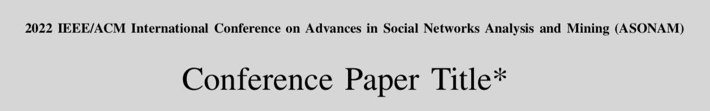

The first page’s left column bottom should look like the following figure after applying all the code mentioned in the step 3:

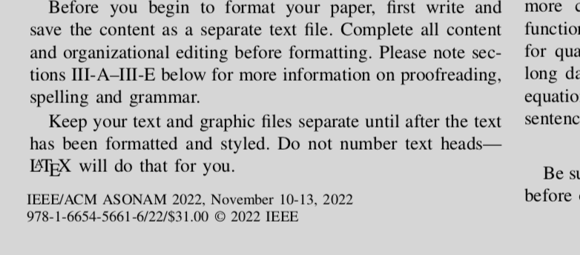

Step 4: Submit your paper to the Camera-ready submission website
Camera-ready paper collection will be handled for IEEE/ASONAM, all collocated events (FAB 2022, FOSINT-SI 2022, HI-BI-BI 2022) and workshops through one website facilitated by easychair:
https://easychair.org/conferences/?conf=crvasonam2022

Step 5: Update your paper if needed
Please check your email regularly for any requests for update to your paper by the ASONAM 2022 Publication Chairs:
- Min-Yuh Day, National Taipei University, Taiwan
imyday (at) gmail (dot) com
- Panagiotis Karampelas, Hellenic Air Force Academy, Greece
pkarampelas (at) gmail (dot) com
and follow any instructions to complete your submission.

The 2022 IEEE/ACM International Conference on Advances in Social Networks Analysis and Mining
(IEEE/ACM ASONAM 2022)
Istanbul, Turkey, (Hybrid), November 10-13 2022
https://asonam.cpsc.ucalgary.ca/2022/

